Procedure on how to generate Crash dump from Windows Servers running on VMware Environment

Procedure to generate crash dump of Windows Virtual Machines.

Procedure to be follow when Windows Virtual Machine went to hung / non-responsive state.

* Do not reboot the server.
* Perform below action with evidence
  + Ping the server
  + RDP the server
  + Access the shares ($) on the server.
  + Access the server from VC console.
* Generate vmsn/vmss file for dump analyse.
  + Note: snapshot/ suspend activity must be performed when error displayed (RDP black screen / error message)

Generate vmsn/vmss and vmem file for crash dump.

1. To check Server configuration file location
   1. In VC console select the VM – Click Action - Edit Setting

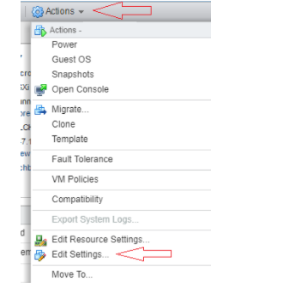

* 1. Select VM Option - General

* 1. In “VM Config File” – Note the path of the configuration file

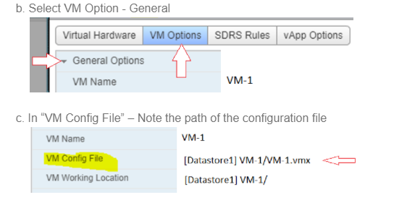

* 1. Click Ok / Cancel

Note: Depending up on Server storage decide which steps (2 or 3) to perform.

1. To Take VMSN / VMEM file using Snapshot
   1. In VC Console -> Select the VM
   2. Click Action -> Select Snapshot -> Click Take Snapshot
   3. Provide Name as per VCC-ops Recommendation (Reference Number – Target date “DD.MMM.YYYY”)
   4. Select “Snapshot Virtual Machine Memory”

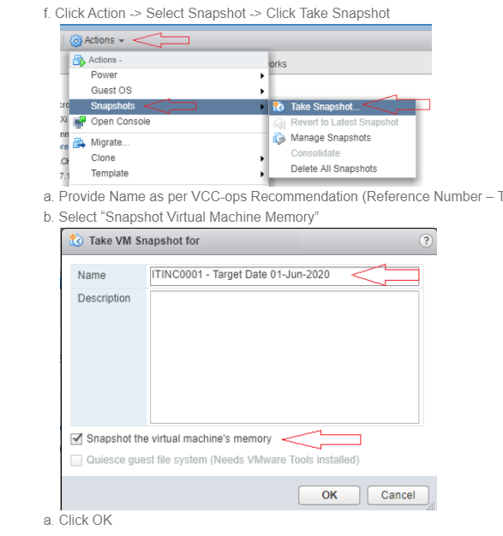

* 1. Click OK

1. To Take VMSS / VMEM file using suspend
   1. In VC Console -> Select the VM
   2. Click Action -> Power -> Click Take Suspend

C. Popup Message appear to confirm -> Click Yes

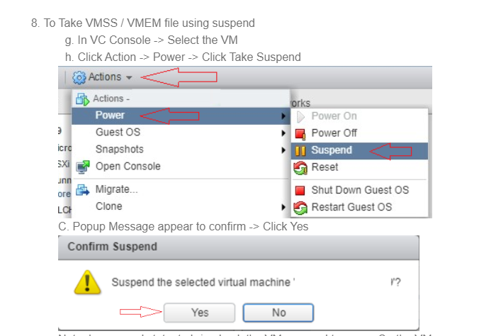

Note: In suspend state, to bring back the VM we need to power On the VM

1. Once snapshot / suspend activity performed on the server
2. Go to the storage folder (performed in step 1)
3. Open Server Folder
4. Select corresponding file and copy to local directory
   1. VMSS / VMEM file for suspend state

* 1. VMSN / VMEM File for Snapshot

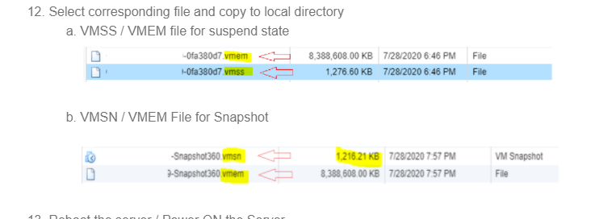

1. Reboot the server / Power ON the Server

   Note:

1. Any issues in copying the files please involve VCC-ops team to copy these files.
2. These files needed by Microsoft to analyze the issue during server hung.
3. These files will be converted as dump file and used for analyze.
4. If any issues occurred during conversion, please involve VCC-ops for conversion.
5. Dump file size must be equal to vmem file.

How to convert the snapshot / suspend file to dump file for analyze.

1. Copy the .vmsn or .vmss and .vmem file to Vmss2core utility folder
2. Download the Vmss2core ([vmss2core-sb-8456865.exe](https://flings.vmware.com/vmss2core?download_url=https%3A%2F%2Fdownload3.vmware.com%2Fsoftware%2Fvmw-tools%2Fvmss2core%2Fvmss2core-sb-8456865.exe)) from VMware Site and place the downloaded file (vmss2core_win.exe) in your local drive (C:\ or D:\).

Note: Place both the Vmss2core file and downloaded .vmsn  or .vmss and .vmem file in the same location.

1. Open Command Prompt with Admin rights
2. Go to Path where Vmss2 utilitiy and VM files are copied
3. Execute command to generate VM files with *.dmp extension
   1. Suspend State

             Command: vmss2core -W8 virtual_machine_name.vmss virutal_machine_name.vmem

* 1. Snapshot State

             Command: vmss2core -W8 virtual_machine_name.vmsn virutal_machine_name.vmem

1. Analyze the created dump in windbg utility

                Windbg Tools: <https://docs.microsoft.com/en-us/windows-hardware/drivers/debugger/debugger-download-tools>

                Vmss2core Tools: <https://flings.vmware.com/vmss2core>